WEEK 6

Mandatory Hands-On

**REACT**

**Create a new React Application with the name “myfirstreact”, Run the application to print “welcome to the first session of React” as heading of that page.**

1. **Define SPA and its benefits**

A Single-Page Application (SPA) is a web application that loads a single HTML page and dynamically updates content without refreshing the page. It uses AJAX and JavaScript to communicate with the server behind the scenes. SPAs provide a smoother and faster user experience. They reduce server load by only loading necessary data. Popular SPAs include Gmail, Google Maps, and Facebook.

1. **Define React and identify its working**

React is an open-source JavaScript library developed by Facebook for building user interfaces. It works using components, allowing you to build reusable UI pieces. React uses a virtual DOM to improve performance and efficiently update the real DOM. It follows a unidirectional data flow which helps manage data predictably.  
React is mainly used for building SPAs and dynamic web apps.

1. **Identify the differences between SPA and MPA**

SPA (Single-Page Application) loads one HTML page and updates content dynamically.  
MPA (Multi-Page Application) loads a new HTML page for each new request or navigation.  
SPA is faster in navigation, while MPA is better for SEO.  
SPA uses JavaScript frameworks like React, while MPA can be built using traditional server-side rendering.  
SPA has less page reload, whereas MPA reloads the full page on every request.

1. **Explain Pros & Cons of Single-Page Application**

Pros: Faster user experience due to no full-page reloads.  
Better performance after initial load and smoother transitions.  
Highly responsive and better suited for mobile apps.  
Cons: SEO can be difficult due to dynamic content.  
Initial load time may be higher and browser history is harder to manage.

1. **Explain about React**

React is a JavaScript library for building fast and interactive user interfaces.  
It allows developers to create reusable UI components. React uses JSX, a syntax extension that allows writing HTML within JavaScript. It relies on a virtual DOM to efficiently render and update views. React is maintained by Facebook and has a strong community and ecosystem.

1. **Define virtual DOM**

The Virtual DOM is a lightweight JavaScript representation of the real DOM.  
React uses it to detect changes and update only the changed elements in the real DOM. It increases performance by avoiding unnecessary DOM manipulations.  
React compares the current virtual DOM with a previous snapshot (diffing) to find changes. Only the modified parts are updated in the actual DOM, making rendering efficient.

1. **Explain the Features of React**

* Component-Based: UI is divided into reusable components.
* JSX: Allows mixing HTML with JavaScript for better readability.
* Virtual DOM: Optimizes performance with efficient updates.
* Unidirectional Data Flow: Easier to debug and maintain.
* Strong Ecosystem: Supported by tools like Redux, React Router, etc.
* *Create-react-app* is installed using the command *npm install -g create-react-app.* In the directory Week 6/ React.

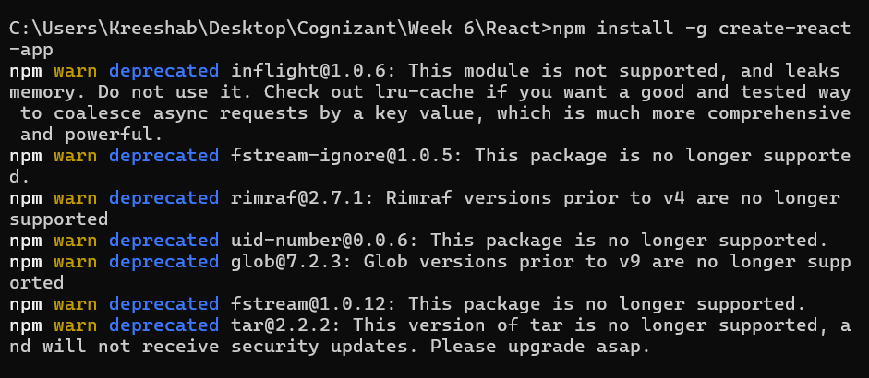

* *Myfirstreact* application is created in the same directory using the command *npx create-react-app myfirstreact.*

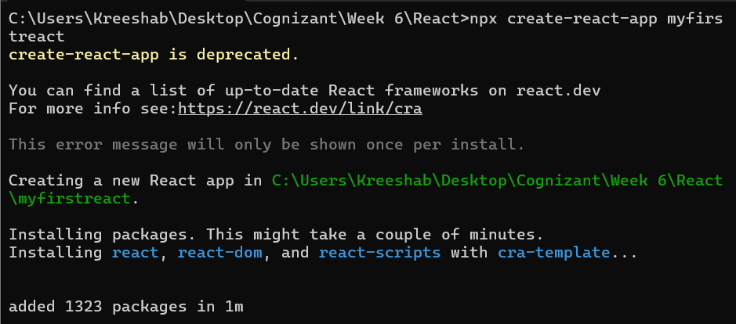

* Navigated into the React app and changed the content of the App.js

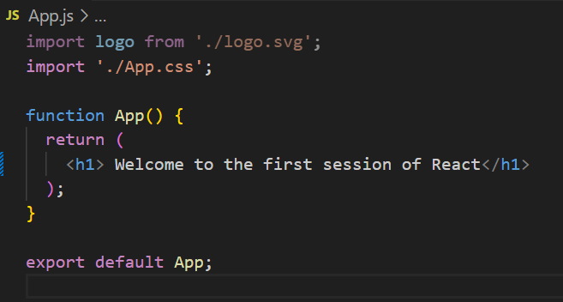

* The Application is executed using the command npm start in cmd.

**Sample Output:**

